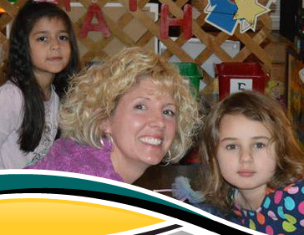

Edgecombe County

Population Size: 54,933

ECPS Number of Students: 6,112

|  |  |  |
| --- | --- | --- |
| Group | Number | Percent |
| American Indian | **7** | **.1%** |
| Asian | **8** | **.1%** |
| Hispanic | **585** | **9%** |
| Black | **3,560** | **58.2%** |
| White | **1,835** | **30%** |
| Multiracial | **118** | **1.9%** |
| Pacific Islander | **3** | **0%** |

## Welcome to our school district. We are focused, connected and ready to serve you and your child. The goal of this brochure is to give you a quick glance at our county and the programs we offer.

## Edgecombe County Public Schools

|  |  |  |
| --- | --- | --- |
| Description | Year(s) | Amount |
| Per capita $ income/year | **2009-2013** | **$16,961** |
| Median household income | **2009-2013** | **$33,960** |
| Persons below poverty level | **2009-2013** | **25.2%** |
| Private nonfarm establishments | **2012** | **773** |
| Private nonfarm employment | **2012** | **12,344** |
| Non-employer establishments | **2012** | **2,646** |
| Manufacturers shipments | **2007** | **1,226,856**  **($1000)** |
| Retail sales | **2007** | **324,723**  **($1000)** |
| Retail sales per capita | **2007** | **$6,204** |

## Economy

## Demography

Central Services Office  
412 Pearl Street, Tarboro, NC 27886

www.ecps.us

ECPS

We serve grades Pre-K through 12

#### Nulla eleifend dolor vel tellus.

Duis id nisl vitae pede vulputate porttitor. Vivamus rhoncus, velit vitae consequat gravida, lacus massa vulputate nisl, id rutrum sem massa non sapien. Morbi vel enim ac lacus lobortis nonummy. Proin tempor. Cum sociis natoque penatibus et magnis dis parturient montes, nascetur ridiculus mus. Nam facilisis erat vitae ligula. Etiam nec felis et neque condimentum aliquet.

**G.W. Bulluck Elementary**

**G.W. Carver Elementary**

**Coker-Wimberly Elementary**

**Princeville Elementary**

**Stocks Elementary**

* Inclusive Environment: High Quality and Child Focused
* Title I At-Risk students
* More at Four
* Fee for Service
* Developmentally Delayed 3 & 4 year old children
* 5 Days a week
* Regular school day
* Transportation
* North Carolina’s Early Learning Standards: The Creative Curriculum & Foundations
* Student Portfolios
* Family Sharing of Student Portfolios
* Center based Classrooms
* 5 Developmental Domains: language, motor, approaches to learning, cognition, and emotional /social
* Play Groups (for those not in day care settings)
* Parents as Teachers Program (birth to age 5)

### Pre-K Program Highlights

# ECPS Pre-K Programs